
Year 8

Mini Test 7

Time

Total Marks: 15 marks
Name: ______________________ Total Time: 25 minutes

Show working and answers on this sheet. Show working in sufficient detail to support your answers. Incorrect answers without supporting reasoning may be allocated zero marks.
Resources Allowed: 1 page A4 notes (1 side). Calculator

Multiple Choice Questions – Choose just one correct answer.

- Convert 14 days into hours. Show your working here
  - 556
  - 336
  - 376
  - 768

- How many days are in 6 fortnights?
  - 104
  - 56
  - 84
  - 88

- In a normal year, how many days are there in April?
  - 30
  - 28
  - 29
  - 31

- What is the date 26 days after 16 May in a non-leap year?
  - 9 June
  - 12 June
  - 11 June
  - 10 June

- Half an hour, converted to seconds, is:
  - 36 seconds
  - 180 seconds
  - 360 seconds
  - 1800 seconds

- Written in 24-hour time, 5:45 pm is:
  - 1345
  - 1745
  - 0545
  - 1545

- Jane left home at 3:54 p.m. to travel to her aunt’s house. She arrived at 5:40 p.m. How long did her journey take?
  - 1 hour 36 minutes
  - 2 hours 24 minutes
  - 1 hour 46 minutes
  - 1 hour 56 minutes

- Converted to 24-hour time 1:25 am is;
  - 1325
  - 1025
  - 0125
  - 0015

- Converted to 12-hour time 2223 is;
  - 2:23pm
  - 22:23pm
  - 10:23pm
  - 10:23am

- David travelled for 5 days 23 hours by boat, then 16 hours by plane and finally 3 days 22 hours by train to be home for his mother’s birthday. How long did his journey take?
- 11 days 23 hours
- 10 days 13 hours
- 8 days 52 hours
- 10 days 22 hours

- The date and time 18 hours and 22 minutes after 11.03 p.m. on 30 September is:
  - 1 October 5.25 p.m.
  - 1 October 5.25 a.m.
  - 31 September 5.25 p.m.
  - 31 September 5.25 a.m.

- William started a marathon at 10:51am and finished at 2.45 p.m. The time that he took was:
- 3 hours 26 minutes
- 3 hours 6 minutes
- 3 hours 24 minutes
- 3 hours 54 minutes

- What time is it hours after 10.41 p.m.
  - 05:11
  - 17:11
  - 18:11
  - 06:11

- If Charlie catches a train at 2:24 p.m. from Circular Quay, what time will he arrive at Central?
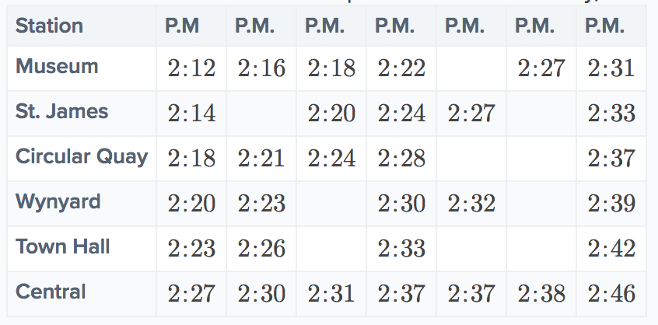
  - 2:30pm
  - 2:27pm
  - 2:37pm
  - 2:31pm

- James is currently at work near Museum station. What is the latest time he can arrive at Museum station if he has to be at Town Hall station by 1:52 p.m.?
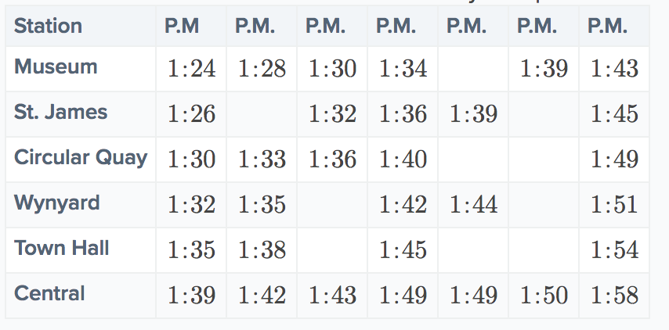
  - 1:34pm
  - 1:30pm
  - 1:39pm
  - 1:28pm

END of TEST

